THE TITLE OF YOUR THESIS/DISSERTATION SHOULD APPEAR LIKE THIS, IN ALL CAPITAL LETTERS AND IN INVERTED PYRAMID FORMAT. THAT MEANS

EACH LINE IS SHORTER THAN THE PREVIOUS LINE,

UP TO FOUR LINES MAXIMUM

by

STUDENT NAME HERE IN ALL CAPITAL LETTERS

Presented to the Faculty of the Graduate School of

The University of Texas at Arlington in Partial Fulfillment

of the Requirements

for the Degree of

DOCTOR OF PHILOSOPHY

or

MASTER OF ARTS IN ….

or

MASTER OF SCIENCE IN…..

(PhD students put only Doctor of Philosophy. Master’s students must include the area of study.)

THE UNIVERSITY OF TEXAS AT ARLINGTON

Month YYYY

(There are only three options for the month on this page. Spring graduation month = May, Summer = August, Fall = December. Then change YYYY to the current year.)

Copyright © by Student Name YYYY

All Rights Reserved



(Replace “Student Name” with your name and YYYY with the current year.)

(The text on this page is centered both vertically and horizontally.)

# Acknowledgements

Replace these Acknowledgements template lines with your own wording. Keep the acknowledgements to no more than one page. Acknowledgements must be written in first person format.

Once you have typed your Acknowledgements, delete any Acknowledgements section template lines that remain.

Month DD, YYYY

(The date on this page is to be the date of your defense.)

(Be sure to omit any leading zeros.)

# Abstract

THE TITLE OF YOUR THESIS/DISSERTATION SHOULD APPEAR LIKE THIS, IN ALL CAPITAL LETTERS AND IN INVERTED PYRAMID FORMAT. THAT MEANS

EACH LINE IS SHORTER THAN THE PREVIOUS LINE,

UP TO FOUR LINES MAXIMUM

Student Name, MS or MA or PhD

The University of Texas at Arlington, YYYY

Supervising Professor: Name (Supervising professor’s name only, No Dr., Mrs., etc.)

Replace these abstract template lines with your own abstract words. Your abstract should not be longer than 1 ½ pages. Once you have typed your Abstract, delete any Abstract section template lines that remain.

Table of Contents

Acknowledgements iii

Abstract iv

List of Illustrations vi

List of Tables vii

Chapter 1 Your Title Here: Use Heading 1 Style 1

Use Heading 2 Style for All Second-Level Subheadings: Sometimes Headings Are Very Long and May Need to Wrap to Two Lines in the Table of Contents 2

Use Heading 3 Style for All Third-Level Subheadings 3

Chapter 2 Your Title Here: Use Heading 1 Style 5

Appendix A Title of Appendix Here 14

Appendix B Title of Appendix Here 16

References 18

Biographical Information 19

(Do not list the Table of Contents in the Table of Contents.)

# List of Illustrations

Figure 1‑1 Jellyfish 1

[Figure 1‑2 This is an example of a multipart figure. It shows (a) is a flower with   
leaves and (b) is a flower without leaves. 2](#_Toc420673125)

Figure 1‑3 Penguins 3

Figure 2‑1 Koala 5

Figure 2‑2 Example of Landscape Figure 12

(Figure titles cannot go all the way to the page number. There must be at least some leading periods between the last word of the title and the page number. Break down long titles with a soft return (SHIFT-ENTER). Inversely, there also cannot be a line of only leading periods and a page number. To move a word down to the next line use a soft return (SHIFT-ENTER) )

# List of Tables

Table 2‑1 Large Table in Landscape Orientation 7

Table 2‑2 Extra Long Continued Table Example 9

(Table titles cannot go all the way to the page number. There must be at least some leading periods between the last word of the title and the page number. Break down long titles with a soft return (SHIFT-ENTER). Inversely, there also cannot be a line of only leading periods and a page number. To move a word down to the next line use a soft return (SHIFT-ENTER).

# Your Title Here: Use Heading 1 Style

HEADING 1 style is centered and title case. Replace this text with your own words. Remember to use HEADING 2 for all second-level subheadings, HEADING 3 for all third-level subheadings and so on. If you need to change the way they look, MODIFY the heading STYLES; don’t change them one at a time. Replace this text with your own words. Remember to use HEADING 2 for all second-level subheadings, HEADING 3 for all third-level subheadings and so on. If you need to change the way they look, MODIFY the heading STYLES; don’t change them one at a time. Replace this text with your own words. Remember to use HEADING 2 for all second-level subheadings, HEADING 3 for all third-level subheadings and so on. If you need to change the way they look, MODIFY the heading STYLES; don’t change them one at a time. For an example of a figure, see below.

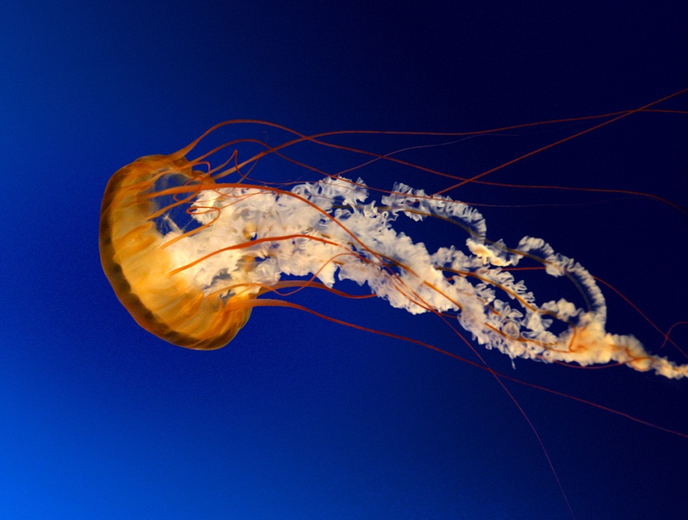

Figure 1‑1 Jellyfish

## Use Heading 2 Style for All Second-Level Subheadings: Sometimes Headings Are Very Long and May Need to Wrap to Two Lines in the Table of Contents

HEADING 2 style is centered, non-bold, and title case. Replace this text with your own words. Remember to use HEADING 2 for all second-level subheadings, HEADING 3 for all third-level subheadings and so on. If you need to change the way they look, MODIFY the heading STYLES; don’t change them one at a time.

Use QUOTE for long quotes that need to be blocked off. Use QUOTE for long quotes that need to be blocked off. Use QUOTE for long quotes that need to be blocked off. Use QUOTE for long quotes that need to be blocked off. Use QUOTE for long quotes that need to be blocked off. Use QUOTE for long quotes that need to be blocked off. Use QUOTE for long quotes that need to be blocked off. Use QUOTE for long quotes that need to be blocked off. Use QUOTE for long quotes that need to be blocked off. Use QUOTE for long quotes that need to be blocked off. Use QUOTE for long quotes that need to be blocked off.

Replace this text with your own words. Remember to use HEADING 2 for all second-level subheadings, HEADING 3 for all third-level subheadings and so on. If you need to change the way they look, MODIFY the heading STYLES; don’t change them one at a time.

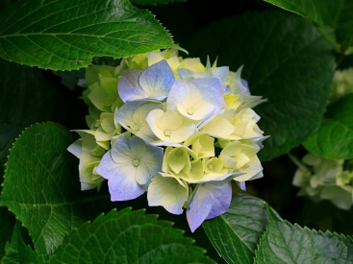

(a) (b)

Figure 1‑2 This is an example of a multipart figure. It shows (a) is a flower with leaves and (b) is a flower without leaves.



Figure 1‑3 Penguins

### Use Heading 3 Style for All Third-Level Subheadings

HEADING 3 style is flush left, non-bold, italicized, and title case. Replace this text with your own words. Remember to use HEADING 2 for all second-level subheadings, HEADING 3 for all third-level subheadings and so on. If you need to change the way they look, MODIFY the heading STYLES; don’t change them one at a time. Replace this text with your own words. Remember to use HEADING 2 for all second-level subheadings, HEADING 3 for all third-level subheadings and so on. If you need to change the way they look, MODIFY the heading STYLES; don’t change them one at a time. Replace this text with your own words. Remember to use HEADING 2 for all second-level subheadings, HEADING 3 for all third-level subheadings and so on. If you need to change the way they look, MODIFY the heading STYLES; don’t change them one at a time.

Use heading 4 style for fourth-level subheadings

HEADING 4 style is flush left, non-bold, non-italicized, and sentence case. Replace this text with your own words. Remember to use HEADING 2 for all second-level subheadings, HEADING 3 for all third-level subheadings and so on. If you need to change the way they look, MODIFY the heading STYLES; don’t change them one at a time. Replace this text with your own words. Remember to use HEADING 2 for all second-level subheadings, HEADING 3 for all third-level subheadings and so on. If you need to change the way they look, MODIFY the heading STYLES; don’t change them one at a time. Replace this text with your own words. Remember to use HEADING 2 for all second-level subheadings, HEADING 3 for all third-level subheadings and so on. If you need to change the way they look, MODIFY the heading STYLES; don’t change them one at a time.

Fifth-level subheadings. HEADING 5 style is run into the body of the paragraph, italicized, and sentence case. You must manually apply this formatting; there is no defined heading style for level-5 headings since these headings are part of a regular paragraph. Replace this text with your own words. remember to use HEADING 2 for all second-level subheadings, HEADING 3 for all third-level subheadings and so on. If you need to change the way they look, MODIFY the heading STYLES; don’t change them one at a time. Replace this text with your own words. Remember to use HEADING 2 for all second-level subheadings, HEADING 3 for all third-level subheadings and so on. If you need to change the way they look, MODIFY the heading STYLES; don’t change them one at a time. Replace this text with your own words. Remember to use HEADING 2 for all second-level subheadings, HEADING 3 for all third-level subheadings and so on. If you need to change the way they look, MODIFY the heading STYLES; don’t change them one at a time.

# Your Title Here: Use Heading 1 Style

Replace this text with your own words. Remember to use HEADING 2 for all second-level subheadings, HEADING 3 for all third-level subheadings and so on. If you need to change the way they look, MODIFY the heading STYLES; don’t change them one at a time. Replace this text with your own words. Remember to use HEADING 2 for all second-level subheadings, HEADING 3 for all third-level subheadings and so on. If you need to change the way they look, MODIFY the heading STYLES; don’t change them one at a time. Replace this text with your own words. Remember to use HEADING 2 for all second-level subheadings, HEADING 3 for all third-level subheadings and so on. If you need to change the way they look, MODIFY the heading STYLES; don’t change them one at a time.

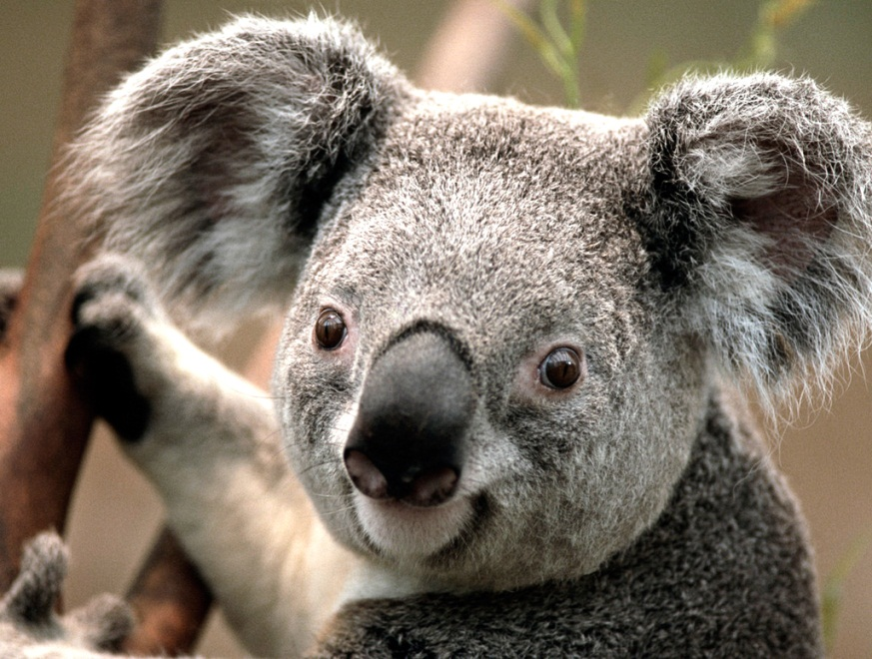

Figure 2‑1 Koala

See Table 2.1 for an example of a landscape table. Replace this text with your own words. Remember to use HEADING 2 for all second-level subheadings, HEADING 3 for all third-level subheadings and so on. If you need to change the way they look, MODIFY the heading STYLES; don’t change them one at a time. Replace this text with your own words. Remember to use HEADING 2 for all second-level subheadings, HEADING 3 for all third-level subheadings and so on. If you need to change the way they look, MODIFY the heading STYLES; don’t change them one at a time. Replace this text with your own words. Remember to use HEADING 2 for all second-level subheadings, HEADING 3 for all third-level subheadings and so on. If you need to change the way they look, MODIFY the heading STYLES; don’t change them one at a time.

See Table 2.1 for an example of a landscape table. Replace this text with your own words. Remember to use HEADING 2 for all second-level subheadings, HEADING 3 for all third-level subheadings and so on. If you need to change the way they look, MODIFY the heading STYLES; don’t change them one at a time. Replace this text with your own words. Remember to use HEADING 2 for all second-level subheadings, HEADING 3 for all third-level subheadings and so on. If you need to change the way they look, MODIFY the heading STYLES; don’t change them one at a time. Replace this text with your own words. Remember to use HEADING 2 for all second-level subheadings, HEADING 3 for all third-level subheadings and so on. If you need to change the way they look, MODIFY the heading STYLES; don’t change them one at a time. See Table 2.1 for an example of a landscape table.

(Table in Landscape Orientation Example - Table is centered on the page with the page number at the left margin. In order to manipulate the placement of page numbers on such pages, all landscape pages must be alone in their own section unless there are multiple landscape pages in a row. )

Table 2‑1 Large Table in Landscape Orientation

|  |  |  |  |  |  |  |  |  |  |  |
| --- | --- | --- | --- | --- | --- | --- | --- | --- | --- | --- |
| 1 | 2 | 3 | 4 | 5 | 6 | 7 | 8 | 9 | 10 | 11 |
| 2 |  |  |  |  |  |  |  |  |  |  |
| 3 |  |  |  |  |  |  |  |  |  |  |
| 4 |  |  |  |  |  |  |  |  |  |  |
| 5 |  |  |  |  |  |  |  |  |  |  |
| 6 |  |  |  |  |  |  |  |  |  |  |
| 7 |  |  |  |  |  |  |  |  |  |  |
| 8 |  |  |  |  |  |  |  |  |  |  |
| 9 |  |  |  |  |  |  |  |  |  |  |
| 10 |  |  |  |  |  |  |  |  |  |  |
| 11 |  |  |  |  |  |  |  |  |  |  |
| 12 |  |  |  |  |  |  |  |  |  |  |
| 13 |  |  |  |  |  |  |  |  |  |  |
| 14 |  |  |  |  |  |  |  |  |  |  |
| 15 |  |  |  |  |  |  |  |  |  |  |
| 16 |  |  |  |  |  |  |  |  |  |  |
| 17 |  |  |  |  |  |  |  |  |  |  |
| 18 |  |  |  |  |  |  |  |  |  |  |
| 19 |  |  |  |  |  |  |  |  |  |  |
| 20 |  |  |  |  |  |  |  |  |  |  |
| 21 |  |  |  |  |  |  |  |  |  |  |
| 22 |  |  |  |  |  |  |  |  |  |  |
| 23 |  |  |  |  |  |  |  |  |  |  |
| 24 |  |  |  |  |  |  |  |  |  |  |

Replace this text with your own words. Remember to use HEADING 2 for all second-level subheadings, HEADING 3 for all third-level subheadings and so on. If you need to change the way they look, MODIFY the heading STYLES; don’t change them one at a time. Replace this text with your own words. Remember to use HEADING 2 for all second-level subheadings, HEADING 3 for all third-level subheadings and so on. If you need to change the way they look, MODIFY the heading STYLES; don’t change them one at a time. Replace this text with your own words. Remember to use HEADING 2 for all second-level subheadings, HEADING 3 for all third-level subheadings and so on. If you need to change the way they look, MODIFY the heading STYLES; don’t change them one at a time.

See Table 2.2 for an example of a long table. Replace this text with your own words. Remember to use HEADING 2 for all second-level subheadings, HEADING 3 for all third-level subheadings and so on. If you need to change the way they look, MODIFY the heading STYLES; don’t change them one at a time. Replace this text with your own words. Remember to use HEADING 2 for all second-level subheadings, HEADING 3 for all third-level subheadings and so on. If you need to change the way they look, MODIFY the heading STYLES; don’t change them one at a time. Replace this text with your own words. Remember to use HEADING 2 for all second-level subheadings, HEADING 3 for all third-level subheadings and so on. If you need to change the way they look, MODIFY the heading STYLES; don’t change them one at a time.

See Table 2.2 for an example of a long table. Replace this text with your own words. Remember to use HEADING 2 for all second-level subheadings, HEADING 3 for all third-level subheadings and so on. If you need to change the way they look, MODIFY the heading STYLES; don’t change them one at a time. Replace this text with your own words. Remember to use HEADING 2 for all second-level subheadings, HEADING 3 for all third-level subheadings and so on. If you need to change the way they look, MODIFY the heading STYLES; don’t change them one at a time. Replace this text with your own words. Remember to use HEADING 2 for all second-level subheadings, HEADING 3 for all third-level subheadings and so on. If you need to change the way they look, MODIFY the heading STYLES; don’t change them one at a time.

Table 2‑2 Extra Long Continued Table Example

|  |  |  |  |  |  |  |  |
| --- | --- | --- | --- | --- | --- | --- | --- |
| 1 | 2 | 3 | 4 | 5 | 6 | 7 | 8 |
| 2 |  |  |  |  |  |  |  |
| 3 |  |  |  |  |  |  |  |
| 4 |  |  |  |  |  |  |  |
| 5 |  |  |  |  |  |  |  |
| 6 |  |  |  |  |  |  |  |
| 7 |  |  |  |  |  |  |  |
| 8 |  |  |  |  |  |  |  |
| 9 |  |  |  |  |  |  |  |
| 10 |  |  |  |  |  |  |  |
| 11 |  |  |  |  |  |  |  |
| 12 |  |  |  |  |  |  |  |
| 13 |  |  |  |  |  |  |  |
| 14 |  |  |  |  |  |  |  |
| 15 |  |  |  |  |  |  |  |
| 16 |  |  |  |  |  |  |  |
| 17 |  |  |  |  |  |  |  |
| 18 |  |  |  |  |  |  |  |
| 19 |  |  |  |  |  |  |  |
| 20 |  |  |  |  |  |  |  |
| 21 |  |  |  |  |  |  |  |
| 22 |  |  |  |  |  |  |  |
| 23 |  |  |  |  |  |  |  |
| 24 |  |  |  |  |  |  |  |
| 25 |  |  |  |  |  |  |  |
| 26 |  |  |  |  |  |  |  |
| 27 |  |  |  |  |  |  |  |
| 28 |  |  |  |  |  |  |  |
| 29 |  |  |  |  |  |  |  |
| 30 |  |  |  |  |  |  |  |
| 31 |  |  |  |  |  |  |  |
| 32 |  |  |  |  |  |  |  |
| 33 |  |  |  |  |  |  |  |
| 34 |  |  |  |  |  |  |  |
| 35 |  |  |  |  |  |  |  |
| 36 |  |  |  |  |  |  |  |
| 37  Table 2.2—*Continued* (Continuation notices must be at the left margin and table title is not repeated. Use the text box method or the Split Tables method to insert a continuation notice.) |  |  |  |  |  |  |  |
| 38 |  |  |  |  |  |  |  |
| 39 |  |  |  |  |  |  |  |
| 40 |  |  |  |  |  |  |  |
| 41 |  |  |  |  |  |  |  |
| 42 |  |  |  |  |  |  |  |
| 43 |  |  |  |  |  |  |  |
| 44 |  |  |  |  |  |  |  |
| 45 |  |  |  |  |  |  |  |
| 46 |  |  |  |  |  |  |  |
| 47 |  |  |  |  |  |  |  |
| 48 |  |  |  |  |  |  |  |
| 49 |  |  |  |  |  |  |  |
| 50 |  |  |  |  |  |  |  |

Replace this text with your own words. Remember to use HEADING 2 for all second-level subheadings, HEADING 3 for all third-level subheadings and so on. If you need to change the way they look, MODIFY the heading STYLES; don’t change them one at a time. Replace this text with your own words. Remember to use HEADING 2 for all second-level subheadings, HEADING 3 for all third-level subheadings and so on. If you need to change the way they look, MODIFY the heading STYLES; don’t change them one at a time. Replace this text with your own words. Remember to use HEADING 2 for all second-level subheadings, HEADING 3 for all third-level subheadings and so on. If you need to change the way they look, MODIFY the heading STYLES; don’t change them one at a time.

See Figure 2‑2 on page 2 for an example of a landscape figure. Replace this text with your own words. Remember to use HEADING 2 for all second-level subheadings, HEADING 3 for all third-level subheadings and so on. If you need to change the way they look, MODIFY the heading STYLES; don’t change them one at a time. Replace this text with your own words. Remember to use HEADING 2 for all second-level subheadings, HEADING 3 for all third-level subheadings and so on. If you need to change the way they look, MODIFY the heading STYLES; don’t change them one at a time. Replace this text with your own words. Remember to use HEADING 2 for all second-level subheadings, HEADING 3 for all third-level subheadings and so on. If you need to change the way they look, MODIFY the heading STYLES; don’t change them one at a time.

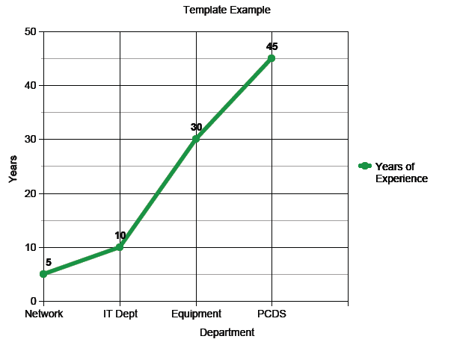

Figure 2‑2 Example of Landscape Figure

(Figure in Landscape Orientation Example – The figure is centered on the page with the page number at the left margin. In order to manipulate the placement of page numbers on such pages, all landscape pages must be alone in their own section unless there are multiple landscape pages in a row. )

Replace this text with your own words. Remember to use HEADING 2 for all second-level subheadings, HEADING 3 for all third-level subheadings and so on. If you need to change the way they look, MODIFY the heading STYLES; don’t change them one at a time. Replace this text with your own words. Remember to use HEADING 2 for all second-level subheadings, HEADING 3 for all third-level subheadings and so on. If you need to change the way they look, MODIFY the heading STYLES; don’t change them one at a time. Replace this text with your own words. Remember to use HEADING 2 for all second-level subheadings, HEADING 3 for all third-level subheadings and so on. If you need to change the way they look, MODIFY the heading STYLES; don’t change them one at a time.

# Appendix A Title of Appendix Here

(Appendices are not required. If your document contains appendices, this is simply how to properly format them.. Break lines of the title with a soft return if it is long (SHIFT-ENTER). Note that this page is alone in its own section due to the text needing to be centered horizontally and vertically on the page.)

Appendix A content goes on this page.

# Appendix B Title of Appendix Here

# 

Appendix B content goes on this page

# References

List reference material here. You may list your references in any order you wish, as long as it is approved by your committee and advisor and is clear and well organized.

Check with your advisor to determine the preferred referencing method of those in your discipline.

You may have only one reference section. References cannot appear at the end of each chapter.

# Biographical Information

Write a paragraph here about your academic career, research interests, degrees earned, projects worked on, and/or future plans.

The biographical information must be in third person format. A biographical information page is required.

(This page is required. Limit this information to no more than one page. Do not list any personal contact information. Also, assume that you will be graduating, so if you include your degree, state that you earned it and not that you’re a candidate for it or in the process of earning it.)